**BACKonLINE™**

**A: Pain behaviour**

01. Do you know what caused your current back pain?

0-Yes

2-No

1-Not sure

02. If yes, choose an option from the list below:

1-Car accident

0-Sport injury

0-Lifting/bending accident

0-Falling down

0-Other trauma

1-Work related

**Please specify**:…………………………

0-Other

1-Nothing specific

03. What do you think is wrong with your back?

04. If you have been treated for back pain, were you satisfied with your treatment?

0-Yes, I was satisfied with the treatment

1-I was neither satisfied nor dissatisfied with the treatment

2-No, I was not satisfied with the treatment

NaN -I was never treated for back pain

05. What medication do you take to manage your back pain? Please tick **all** options that apply

1-Paracetamol

1-Ibuprofen

1-Codeine

1-Diazepam

1-Amitriptyline

1-Duloxetine/Cymbalta

1-Gabapentin

1-Tramadol

1-Hydrocodone

1-Cortisone

1-Acetaminophen

1-Glucosamine

1-Valium

1-Naproxen

1-Other

0-I don’t take any medication for my back pain

06. How effective is the medication in reducing your back pain?

0-Effective

1-Not sure

2-Ineffective

07. Where is your pain? Please tick **all** body areas that apply

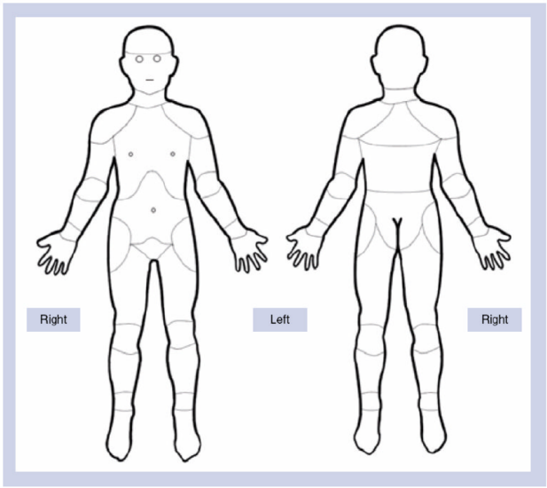1-Neck

1-Right shoulder

1-Left shoulder

1-Right arm

1-Left arm

1-Upper back

1-Lower back

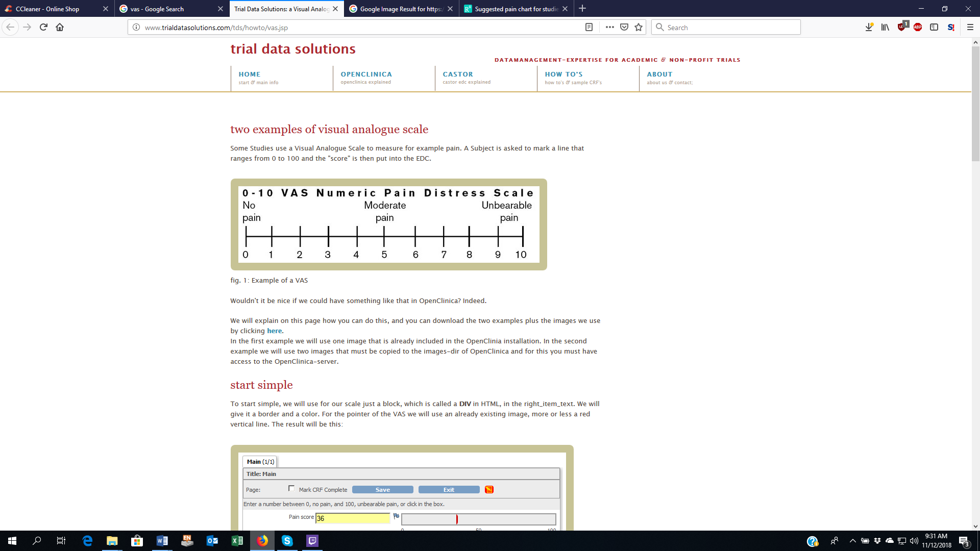1-Right buttock

1-Left buttock

1-Right hip

1-Left hip

1-Right leg

1-Left leg

08. Is your pain there all the time?

2-My pain is there all the time

0-My pain comes and goes

1-Not sure

09. What type of pain is it? Please tick **all** options that apply

1-Deep

1-Nagging

1-Dull

1-Sharp

1-Shooting

1-Dull ache

1-Like lightning

1-Burning

1-Pressure

1-Stinging

1-Aching

1-Throbbing

2-Spread over a wide area

10. When is your pain at its worst?

1- in the morning

1- at the end of the day

2-My pain is there all day long

11. Can you ease your back pain?

0-Yes

1-Sometimes

2-No

12. How do you ease your back pain? Please tick **all** options that apply

0-Medication/pain killers

0-Rest

0-Walking

0-Standing

0-Sitting

0-Exercise

0-Massage

0-Hot pack

0-Cold pack

0-Other

2-I am unable to ease my back pain

13. In general, is your back pain getting better, staying the same or getting worse?

0-My pain is getting better

1-My pain has stayed the same

2-My pain is getting worse

14. From the list below, please tick **all** the activities that make your pain worse.

0-Sitting relaxed

0-Sitting up straight

0-Standing

0-Walking

0-Lifting

0-Forward bending

1-Any activity that I do for a long period of time increases my back pain

2-Everything I do causes me pain

15. From the list below, please tick **all** the activities that stop or decrease your pain.

0-Walking

0-Changing positions

0-Sitting down

2-Avoiding activities that causes me pain

0-Stretching my back

0-Moving about

1-Painkillers

2-Nothing I do stops my pain

16. Is this the first time you have experienced this type of pain?

0-Yes

2-No

1-Not sure

17. If you had a previous episode of back pain, what helped in making your pain better? Please tick **all** options that apply

1-Medication/ painkillers/ injections

1-Rest

0-Exercise

1-massage/ physiotherapy/ chiropractic/ osteopathy

2-Nothing helped

18. Other than your back pain, do you experience other odd sensations in your back or legs (for example: crawling sensation, stinging, pressure)

2-Yes

0-No

1-I don’t know

19. Please tick **all** the areas where you experience this feeling:

1-Neck

1-Right shoulder

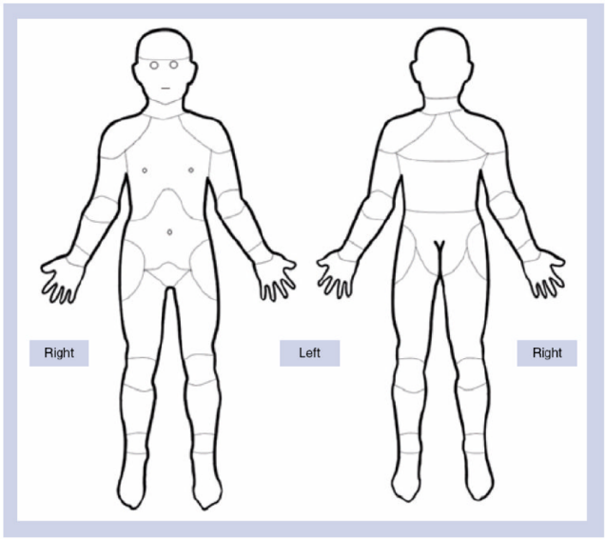1-Left shoulder

1-Right arm

1-Left arm

1-Upper back

1-Lower back

1-Right buttock

1-Left buttock

1-Right hip

1-Left hip

1-Right leg

1-Left leg

|  |  |
| --- | --- |
| Number of hours | score |
| <5 | 2 |
| 5-7 | 1 |
| 8+ | 0 |

20. On average, how many hours do you sleep?



21.Does your back pain wake you up every night?

2-Yes

0-No

22. If you wake up with back pain, can you get back to sleep?

0-Yes

1-Sometimes

2-No

**B: Back pain and work:**

23. how strongly do you agree with this statement : ‘I believe that my job caused /contributed to my back pain’

2-Agree

1-Neither agree nor disagree

0-Disagree

NaN- I don’t work

24. Do you feel supported by your boss and/or co-workers?

0-Yes

2-No

1-I don’t know

NaN -Not applicable

25. How is your back pain affecting your work?

0-Not at all

0-Sometimes

1-Frequently

2-I am unable to work because of my back pain

26. Are you off work right now because of your back pain?

2-Yes

0-No

0-I don’t work

27. How long have you been off work?

0-Less than 3 months

1-Between 1 to 6 months

2-More than 6 months

28. How likely it is that you would return to work within six months?

0-Likely

1-Not sure

2-Unlikely

**C: Back pain and lifestyle:**

**Do you agree with the following statements?**

29. ‘I can’t do my normal daily activities because of my back pain’

2- agree

1- neither agree nor disagree

0- disagree

30. ‘My back pain is negatively affecting my social life’

2- agree

1- neither agree nor disagree

0- disagree

31. ‘My back pain is affecting my relationship with my significant other’

2- agree

1- neither agree nor disagree

0- disagree

32. ‘I don’t know what makes my back pain worse or what eases it ‘

2- agree

1- neither agree nor disagree

0- disagree

**Perception of back pain:**

**Do you agree with the following statements?**

33. ‘My back pain makes me feel stressed/anxious’

2- agree

1- neither agree nor disagree

0- disagree

34. ‘Stress increases my back pain’

2- agree

1- neither agree nor disagree

0- disagree

35. ‘Physical activity increases my back pain’

2- agree

1- neither agree nor disagree

0- disagree

36. ‘Since my back pain started, I feel more tired’

2- agree

1- neither agree nor disagree

0- disagree

37. ‘I have lost interest and/or pleasure in doing things because of my back pain’

2- agree

1- neither agree nor disagree

0- disagree

38. ‘I don’t think my family and friends understand what I’m going through with my back pain.’

2- agree

1- neither agree nor disagree

0- disagree

39. ‘I don’t think my back pain will ever go away.’

2- agree

1- neither agree nor disagree

0- disagree

**End of BACKonLINE™**